Read Me for key understanding (Concept, Target Range, Calculation)
Microscopic Evaluation - Zooglea Bulking vs Nutrient Deficiency

- About this test
This document serves as guidance to identify a Nutrient Deficiency condition, differentiated from a Zooglea overgrowth condition causing slime bulking, through Microscopic Evaluation. Essential information is presented in the form of Q&A in the sections below. In the next page, you will have to enter the Observation ID that best matches your conclusions of either a (Zooglea) Slime bulking condition, or one of Nutrient deficiency, or neither.

- Why is Microscopic Evaluation important?
Microscopic evaluation is very important to help you observe your bugs very closely, to assess if your biological treatment is ideal, or to accurately understand underlying conditions causing process upsets or poor treatment efficiency. So, microscopic evaluation is a critical tool to diagnose and troubleshoot a problem with accuracy, and necessitates routine monitoring. This helps you prevent toxic upsets and implement operational changes at the right time.

- What do you need to set up for Microscopic Evaluation?
Equipment required:
- Research grade phase contrast microscope
- 10x and 100x brightfield objectives that yield 100x, 1000x magnification, respectively
- 25-mm X 75-mm microscope slide
- 22-mm X 22-mm (No. 1) glass cover slip
- Immersion oil
- Gram stain
- Neisser stain

Use Brightfield Illumination. Do not use Phase Contrast Illumination.
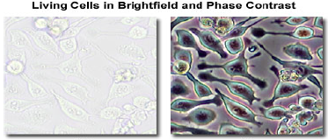

Sampling and Sampling Frequency:
- Obtain mixed liquor samples of 1-2 Liters, at points of good mixing, at either the effluent end of the Aeration Basin or the channel between the Aeration Basin and Secondary Clarifier.
- Take MLSS samples below the surface, avoiding any foam or floating solids. If the foam is excessive, collect a separate sample.
- Sampling frequency depends on prevailing circumstances:
  - Daily during episodes of process upset like bulking, or during critical process changes
  - Weekly for process control
  - Once every SRT or Sludge Age for Routine characterization

Sample Preparation (Wet Mount):
- Shake to completely mix the sample.
- Place 1 drop or 0.05 mL of sample using a clean, disposable Pasteur pipet, onto the center of the slide.
- Gradually lower and drop the cover slip across the sample from left to right
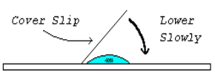
- Place a clean paper towel across the entire cover slip and slowly apply pressure as you roll your hand across the sample, while slightly increasing pressure from left to right.

Observation (100X using 10X objective):
Examine the wet mount under phase contrast illumination at 100X using 10X objective, and check for the following:
- Floc Size
- Floc Characteristics
- Protozoa and Other Macroorganisms
- Non-biological Organic and Inorganic Particles
- Bacterial Colonies
- Cell Dispersed in Bulk Solution
- Effects of Filamentous organisms on floc structure
- Filamentous Organism Abundance

- What is Slime Bulking and Foaming?
Bulking is a phenomenon of sludge solids floating on the surface, without separating from the water by settling and compaction. Slime bulking is when there is presence of a sticky, gray-ish slimy substance called Extracellular Polysaccharide (EPS) or Glycocalyx. You can also observe this in the form of sticky, gray foam. The sludge will have a slimy consistency, as if it had been mixed with polymer.

- What causes excess slime production?
Some amount of ‘slime’ produced is normal. Under low food and nutrient (starvation) conditions, floc-forming bacteria release EPS, which cements them together to form flocs that settle down by gravity. However, excessive slime production is undesirable, as the slime prevents food from entering the floc for digestion, and also affects settling rates and solid-liquid separation. Excess EPS occurs because of the following:
- Zooglea overgrowth - Zooglea are finger-like bacteria that contribute to floc-formation. However, their overgrowth can hinder settling. They grow excessively under conditions of High Organic loading, High F/M Ratio, Excess Organic Acids in the mixed liquor due to low DO or septic conditions

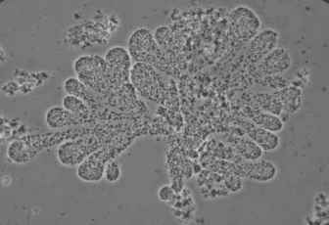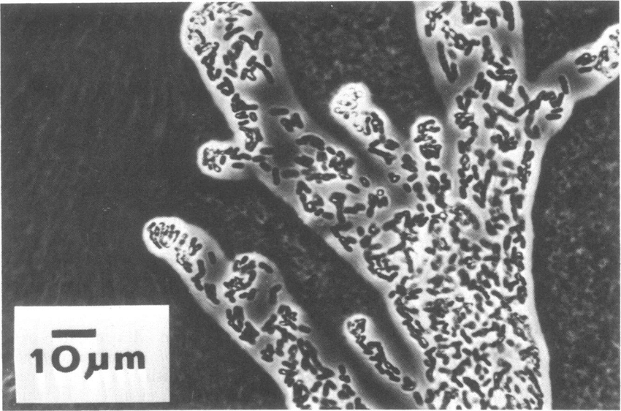
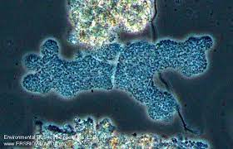
- Nutrient Deficiency - Very low availability of nutrients like Nitrogen, Phosphorus

The aim of this document is to help you differentiate between the two conditions that cause excess EPS or slime, and accurately identify the cause of your problem.

- What tests do you need to do to differentiate between the two conditions?
You can identify excess EPS or slime from the naked eye, but microscopic evaluation provides details to understand the exact cause. You’ll need to run two tests:
- India Ink Test - this test confirms the presence of excess slime
- Anthrone Test - this test confirms based on polysaccharide values, if excess slime is the result of conditions causing excess zooglea or nutrient deficiency

Results of the tests that point to a Zooglea overgrowth condition or Nutrient Deficiency:
Condition | India Ink Test | Anthrone Test
No Slime Bulking,  No Nutrient Deficiency | Ink penetrates most of the flocs. Flocs mostly appear black.  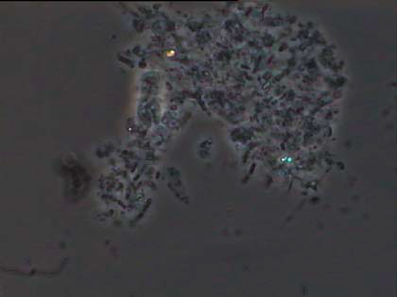 | < Not required >
Slime bulking, from Zooglea overgrowth | Ink does not penetrate most of the floc. Flocs mostly appear white.  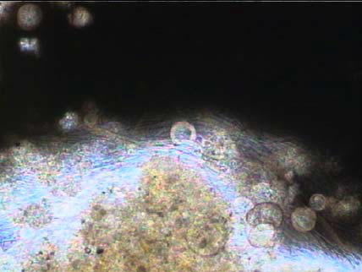 | Blue-Green complex in solution => Polysaccharides (carbohydrates). Normal polysaccharide values of 10-25%
Nutrient Deficiency | Ink does not penetrate most of the floc. Flocs mostly appear white.   | Blue-Green complex in solution => Polysaccharides. High polysaccharide values, over 25%

- How do you do the India Ink Test?
Lab procedure
- Place a small drop of mixed liquor on a clean, grease-free slide.
- Add a small drop of water-soluble India ink. This can be purchased at an art supply store.
- Cover with a cover slip. Be sure to remove excess fluid from around the slide by touching a piece of paper towel to the edge of the slide to draw off the excess.
- Place a drop of immersion oil directly on top of the cover slip and view the slide using the 100X oil immersion lens.
- Observe the sample using brightfield with the maximum light possible. Do not use the phase contrast condenser.

When India ink is added to a drop of mixed liquor, the carbon black particles from the ink penetrate the flocs from outside to the inside, staining them black. When there is excess EPS or slime, the ink particles are stopped from penetrating the flocs, which appear white instead. Thus, the India Ink Test gives confirmation of the presence or absence of a Slime Bulking / Foaming condition.

Flocs stain Black (No Extra Slime) Flocs appear White (Excess Slime)


Ideal condition: Most flocs stain black. This will mean there’s no Slime bulking problem caused by either Zooglea overgrowth or Nutrient Deficiency.

- How do you do the Anthrone Test?
About the test
- The anthrone polysaccharide test is a chemical procedure to measure the bacterial polysaccharide content. This is an extensive time-consuming test, but gives accurate results to identify nutrient deficiency or Zooglea overgrowth.
- It requires a TSS concentration of 2000 mg/L or higher. Aerated lagoons can determine polysaccharide concentrations by centrifuging samples. Centrifuging is required as a significant fraction of the biological TSS may not readily be captured by gravity settling.
- It measures glucose and expresses results in μg/mL (microgram per mL). This can be converted to carbohydrate per gram of activated sludge.
- If the India Ink test stains most of the floc black, you don’t have to do the Anthrone test.

Lab Setup, Procedure and Results
- Equipment and glassware:
  - UV Spectrophotometer
  - Vortex mixer
  - Mantle Heater / Water Bath
  - Test tubes, pipet, wash bottle
- Chemicals or Reagents:
  - Acetic / Nitric reagent - Add 150 mL of 80% glacial acetic acid and 15 mL of concentrated nitric acid
  - Anthrone test reagent - Add 200 mg of Anthrone in 100 mL of concentrated Sulfuric acid (H₂SO₄). Prepare fresh and chill for two hours before use.
  - Glucose
  - Other carbohydrates if desired
- Lab Procedure:
  - In a test tube, combine 3 mL acetic/nitric reagent with a specified amount (0.5g or 1g) of the sample in a vortex mixture.
  - Place the tube in a 100℃ water bath for 30 minutes. Cool for 15-20 minutes. Centrifuge the contents and discard the supernatant.
  - Wash the residue with distilled water. Allow 10mL of 67 percent sulphuric acid to sit for 1 hour after washing.
  - Obtain 1 mL of the above-mentioned solution and dilute to 100mL. To this, add 10 mL of anthrone test reagent and mix thoroughly.
  - Heat the tubes for 10 minutes in a boiling water bath, then cool and measure the color at 620 or 630 nm.

- Determining Polysaccharide (carbohydrate or glucose) concentration:
  - Prepare a standard curve (graph) of absorbance against glucose concentration.
  - Determine the amount of glucose in the unknown sample by plotting a standard curve of A620 on the Y-axis and concentration of Glucose on the X-axis.
- Interpretation:
- Anthrone positive result: Presence of a Blue-Green complex in solution, shows the presence of carbohydrates.
- Presence of a high amount of carbohydrates (> 25%) occur when there is nutrient deficiency.
- An anthrone polysaccharide content of less than 25% is normal and an indication that nutrients are not deficient. Nutrient addition is either balanced or over-addition may be occurring (check Aeration Basin effluent for Ammonia and Orthophosphate concentration levels)

- Next step:
In the next page, the conditions causing Slime bulking described in this guide are tabulated and assigned ID’s. You will be required to enter the Observation ID that best matches your conclusions of either Zooglea overgrowth or Nutrient deficiency causing the excess slime (if such be the case). Jarvis will use this input to test or check if it’s a sign of a problem within your facility.

